The University of Azad Jammu and Kashmir, Muzaffarabad

Name: Alishba Zakir
Roll No: 2024-SE-02
Course: Computer Networks
Course Code: SE-2203
Lab# 03
Submitted To: Engr. Dr. Asma Javaid
Submitted By: Alishba Zakir
Date: Mar, 2026

Department Of Software Engineering

## Lab Report: Ethernet Cable Termination (RJ45)
1. Objective:
The primary objective of this lab was to learn how to properly terminate a Category 6 (Cat6) or Category 5e (Cat5e) Unshielded Twisted Pair (UTP) cable using RJ45 connectors according to
the TIA/EIA-568B standard.
2. Tools & Materials Required
To complete this task, the following equipment was used:
UTP Cable: Cat5e or Cat6.
RJ45 Connectors: Two modular plugs.
Crimping Tool: To secure the connector to the cable.
Wire Stripper: To remove the outer jacket of the cable.
LAN Tester: To verify the connectivity and pin configuration.
3. Wiring Standards (T568B)
In this lab, we followed the T568B standard, which is the most commonly used wiring
scheme. The color coding for the pins (1 to 8) is as follows:
| 1 | White-Orange |
| 2 | Orange |
| 3 | White-Green |
| 4 | Blue |
| 5 | White-Blue |
| 6 | Green |
| 7 | White-Brown |
| 8 | Brown |

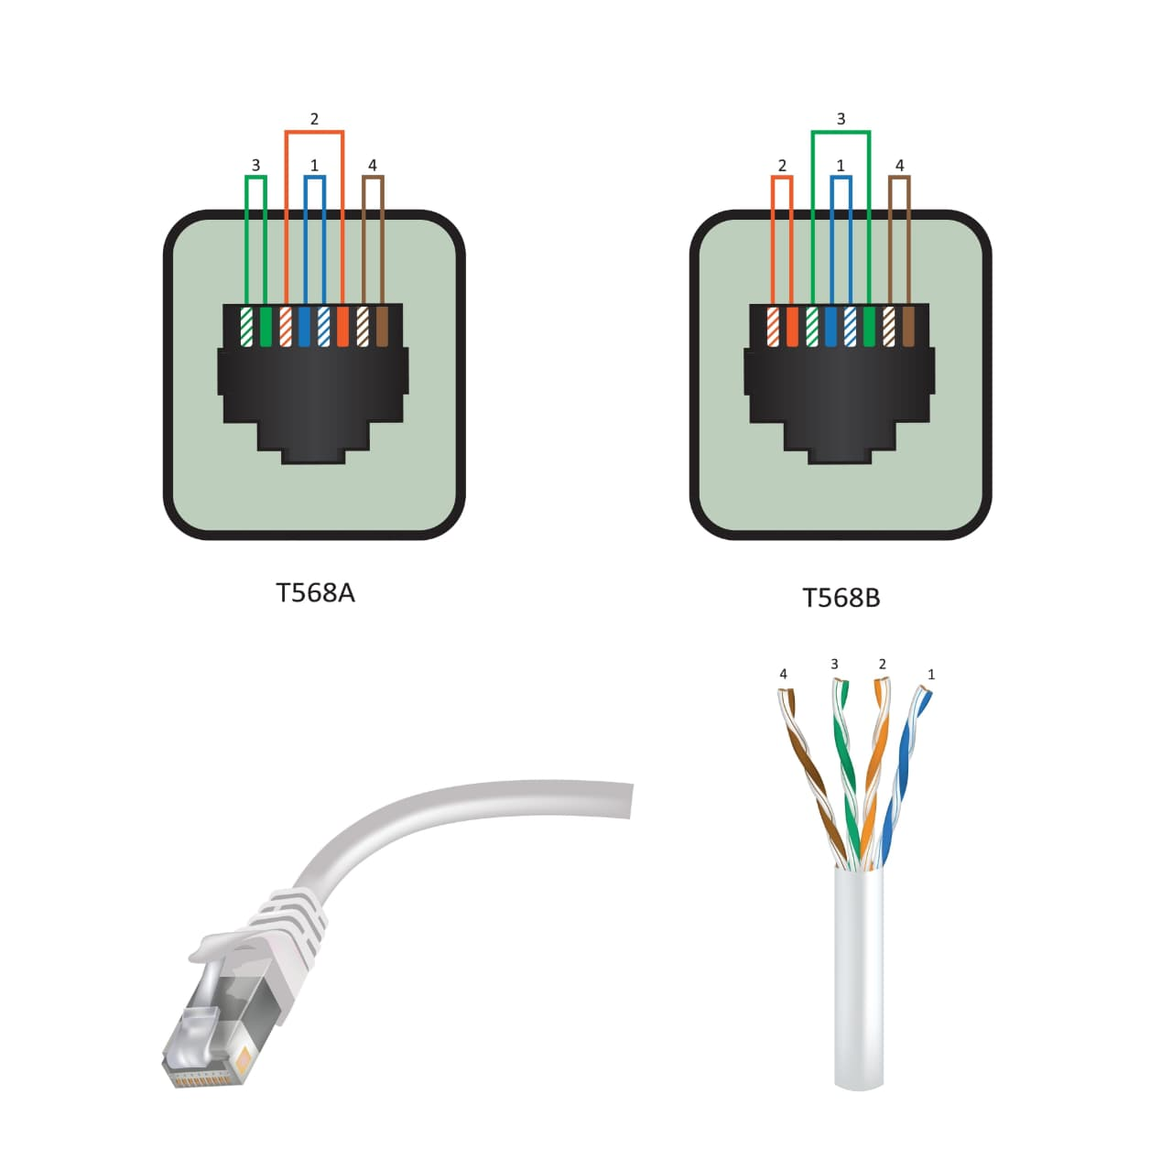
4. Procedure:
The following steps were performed to create the cable:
1. Stripping: Approximately 1 inch of the outer jacket was removed using the wire stripper, taking care not to nick the internal copper wires.
2. Untwisting: The four pairs of wires were untwisted and straightened out.
3. Arranging: The wires were arranged side-by-side according to the *T568B* color code sequence.
4. Trimming: The wires were trimmed to about 0.5 inches in length using the cutting blade on the crimping tool to ensure they were level.
5. Insertion: The wires were firmly pushed into the RJ45 connector until they reached the end of the plug.
6. Crimping: The connector was placed into the crimping tool and squeezed firmly to push the metal pins into the wires and secure the jacket.
7. Repetition: Steps 1 through 6 were repeated for the other end of the cable.
5. Testing and Results:
Once the cable was ready, it was connected to a *LAN Tester*.
Observation: The lights on the tester blinked in sequence (1 through 8) on both the master and remote units.
Conclusion: This indicated that all pins were correctly mapped and the cable was fully functional.

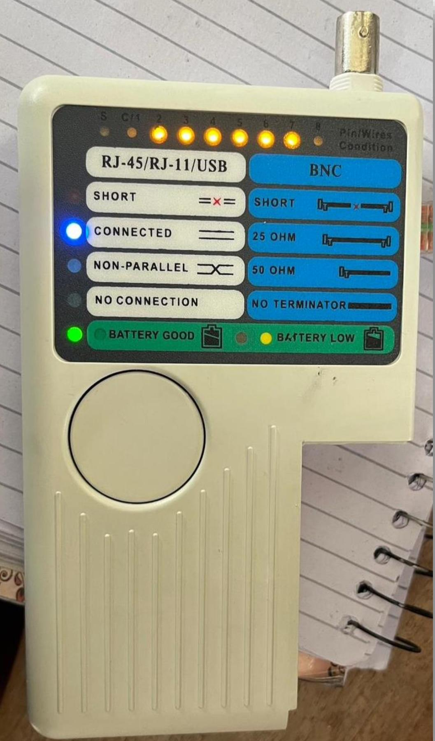

6. Conclusion:
The lab was successful. I learned how to identify the internal structure of a UTP cable and the importance of following standardized color codes to ensure network communication.

